SP26 Homework2 Object Detection

Option 1: Training Optimization

Introduction
This assignment focuses on improving the training process of a 2D object detection model. The objective is to analyze how different training strategies affect detection performance and to identify configurations that improve accuracy. Experiments were conducted using the COCO128 dataset, along with additional custom annotated data to further enhance performance.

Baseline Model Setup
The baseline model was implemented using YOLOv8n pretrained on the COCO dataset. The model was trained on the COCO128 dataset using default settings.
Details:
- Model: YOLOv8n
- Dataset: COCO128
- Epochs: 30
- Image size: 640
- Optimizer: Default (SGD-based)

Modified / Improved Training Approach
- Increasing Training Duration (Epochs)
Epochs increased: 30 → 50
Increasing the number of epochs allows the model to train longer and better learn patterns from the dataset. This resulted in a noticeable improvement in both mAP@0.5 and mAP@0.5:0.95, indicating better convergence and learning.
- Increasing Image Resolution
Image size increased: 640 → 800
Higher resolution images provide more visual detail, improving the model’s ability to detect small or distant objects. Performance improved moderately, showing better object localization.

- Combined Training Strategy
epochs = 50 + image size = 800
Combining both strategies allows the model to benefit from longer training and richer visual features. This produced the best performance among basic configurations.
- Adding Custom Annotated Dataset
- Added 60 custom manually labeled images
- Merged with COCO128 dataset
Custom data introduces domain-specific variations such as lighting, object arrangement, and real-world scenarios. It leads to improved generalization and increased detection performance further.
- Optimizer Modification: AdamW (Without Tuning)
The optimizer was changed from the default configuration to AdamW without modifying other training parameters. This was done since AdamW is a widely used optimization algorithm in deep learning and is known for its ability to improve convergence in certain tasks. This change resulted in a significant decrease in performance compared to the baseline. This indicates that simply switching optimizers without proper tuning can negatively impact training.

- Advanced Optimization (AdamW + Cosine Scheduler)
The AdamW optimizer was combined with cosine learning rate scheduling and a warmup strategy. It was done since advanced optimization techniques such as cosine scheduling and warmup can stabilize training and improve convergence by adjusting the learning rate dynamically during training. This configuration produced the best performance among all experiments. It demonstrates that optimization strategies are highly sensitive to hyperparameter settings, and proper tuning is essential for achieving optimal results.

Experiment | Epochs | Img Size | Optimizer | mAP@0.5 | mAP@0.5:0.95
Baseline | 30 | 640 | default | 0.795 | 0.622
Epochs50 | 50 | 640 | default | 0.841 | 0.660
Img800 | 30 | 800 | default | 0.820 | 0.636
Final (50,800) | 50 | 800 | default | 0.852 | 0.674
Combined_custom | 50 | 800 | default | 0.874 | 0.699
AdamW (adamw_cosine) | 50 | 800 | AdamW | 0.907 | 0.725
AdamW_test | 50 | 800 | AdamW | 0.598 | 0.404
Table 1: Performance comparison of different training configurations

Results and Comparison

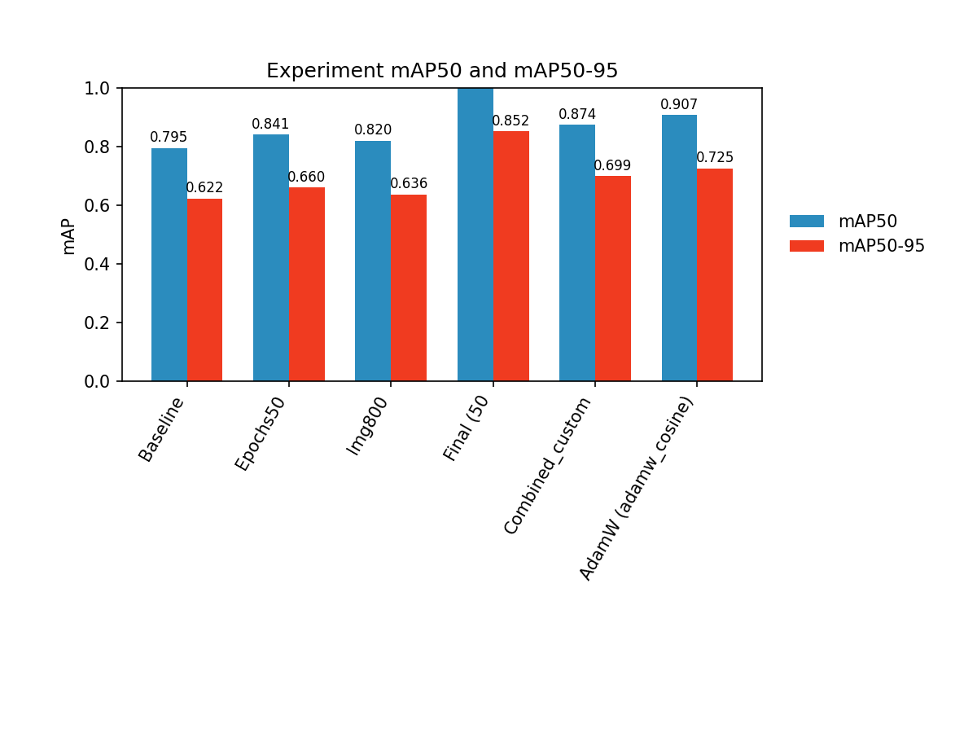
Figure 1: Comparison of mAP@0.5 across different training configurations. The optimized models show consistent improvements over the baseline.

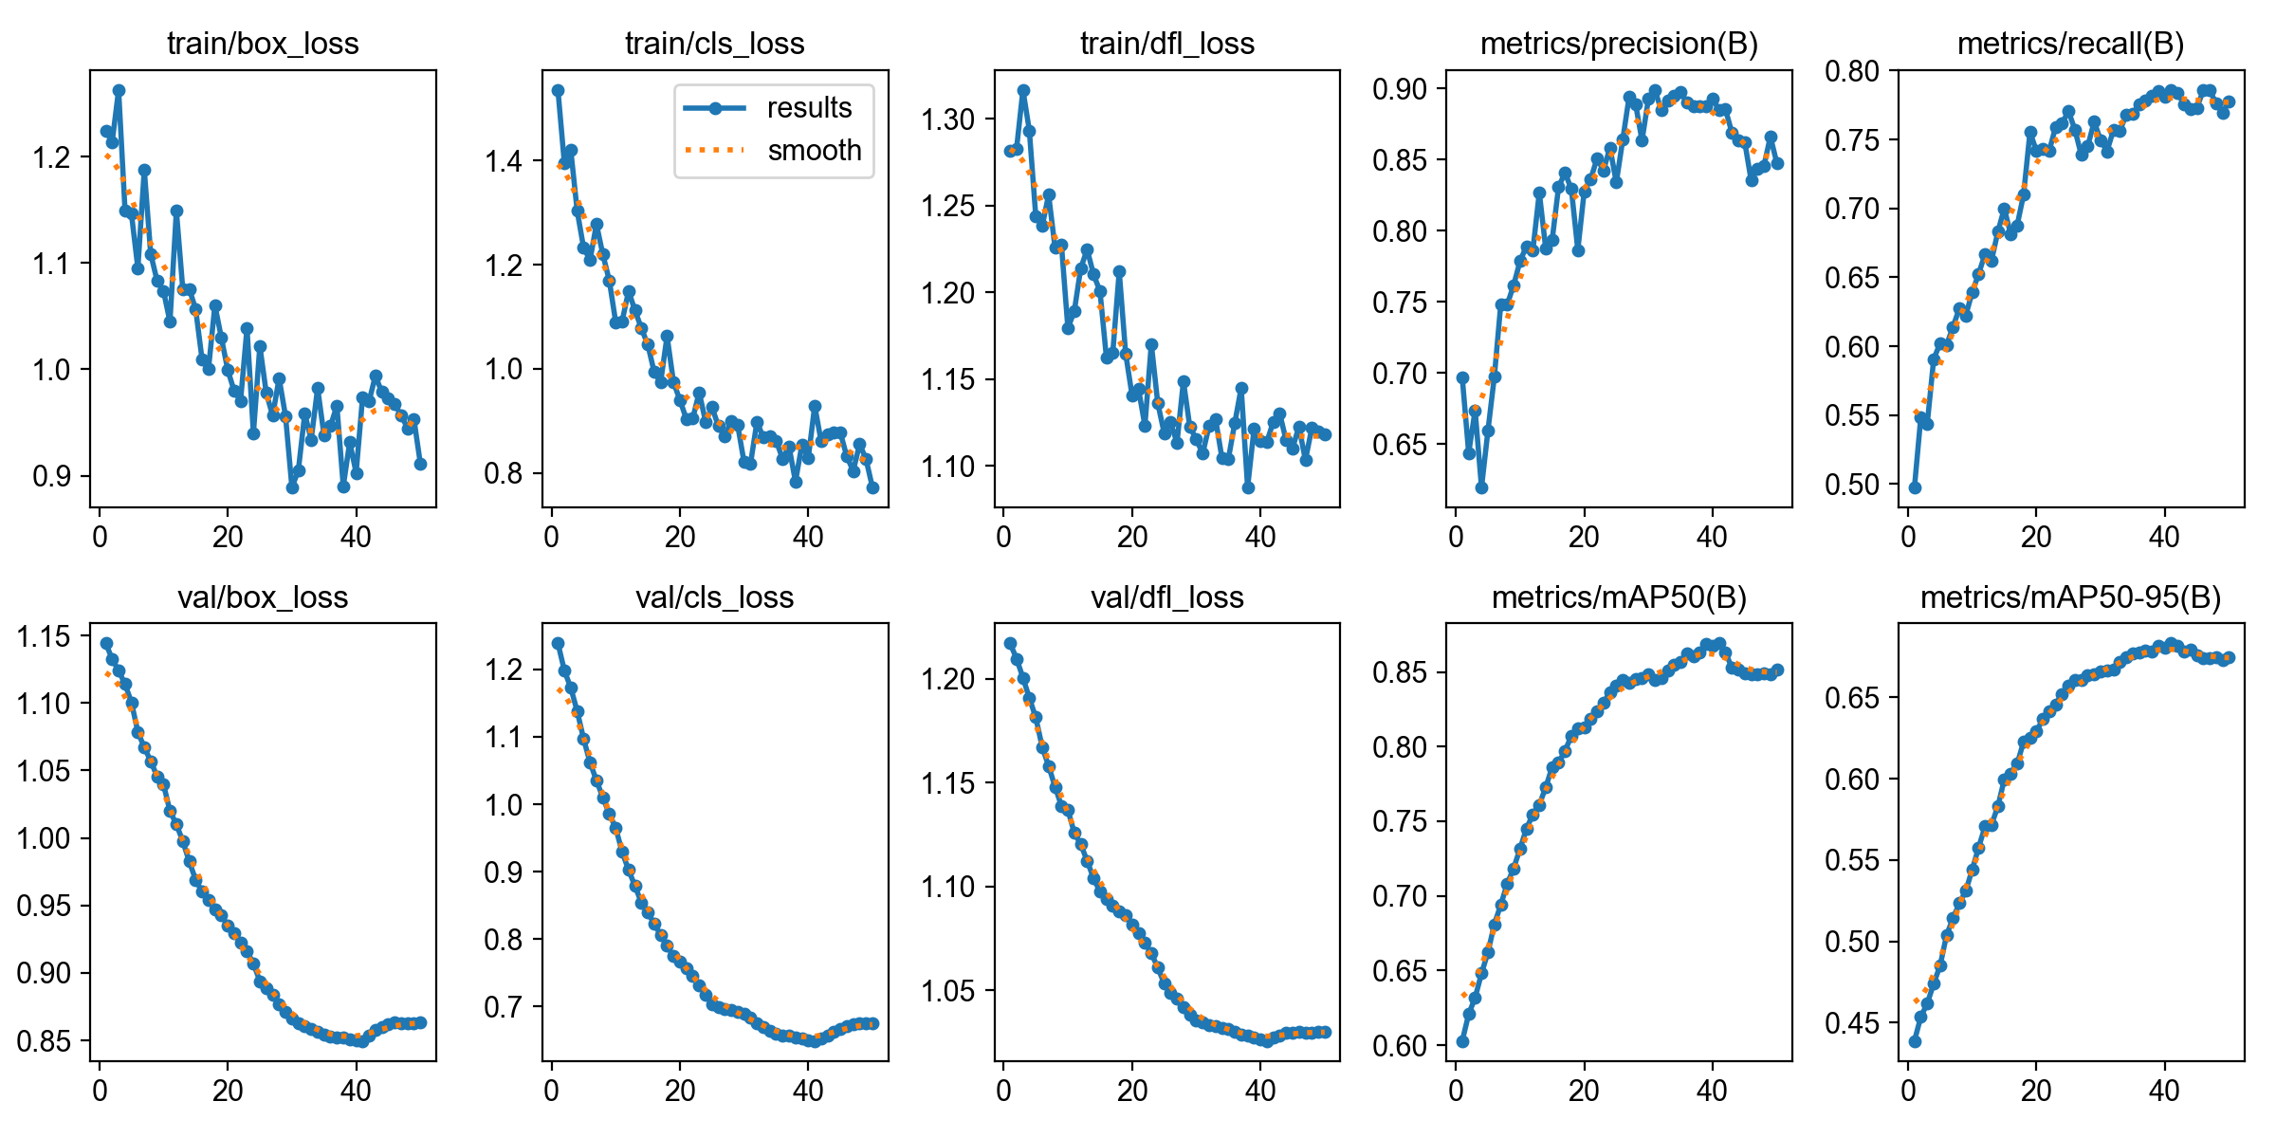
Figure 2: Training curves showing decreasing loss and increasing mAP over epochs for combined model, indicating effective model convergence.

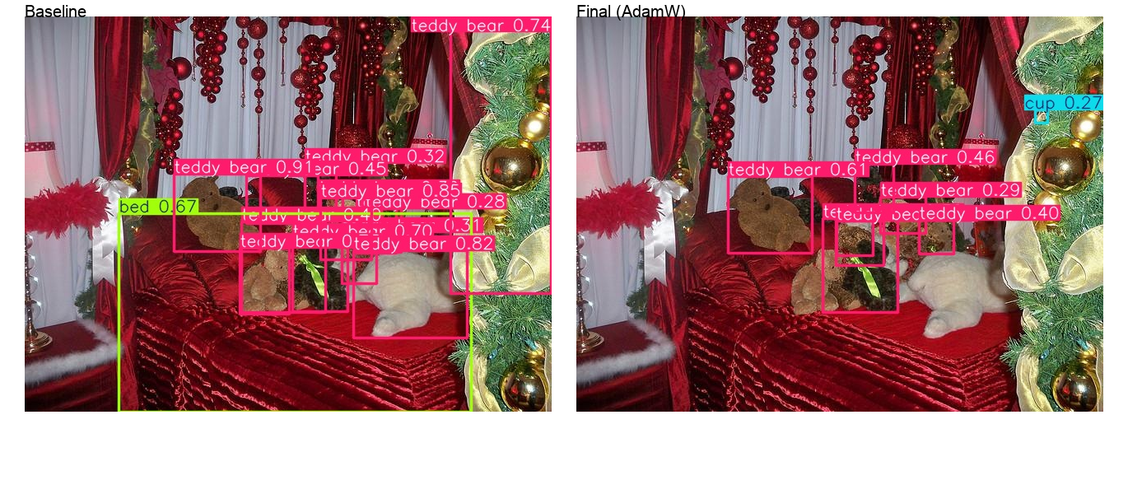
Figure 3: Comparison of detection results. The baseline model produces overlapping and low-confidence detections, while the optimized model (FinalAdamW) shows more stable and accurate predictions.

Comparison of COCO-style Evaluation Results
To evaluate the effectiveness of training improvements, COCO style metrics including the mAP@0.5 and mAP@0.5:0.95 were compared for all the experiments. The baseline model got an mAP@0.5 of 0.795 and mAP@0.5:0.95 of 0.62. It was thus observed that on increasing the number of epochs the performance improved to 0.841 and 0.660 respectively, while on increasing image size resulted in moderate improvements. Combining both the strategies further improved performance to 0.852 (mAP@0.5) and 0.674 (mAP@0.5:0.95). The addition of the custom annotated data increased the performance to 0.874 and 0.699.
The highest performance was achieved using AdamW with cosine learning rate scheduling, reaching 0.907 and 0.725. In contrast,was using AdamW without proper tuning which resulted in a significant drop in performance, demonstrating the importance of correct hyperparameter configuration.

Analysis
It can thus be implied that the training strategy of the model has a significant influence in the performance of object detection models. An increase in the number of epochs from 30 to 50 caused significant improvement in the performance. It indicates that the baseline model had not fully converged. This suggests that sufficient training duration is essential for the model to learn meaningful feature representations.
Increasing the input image size from 640 to 800 also led to improved performance, even though the impact was lesser compared to increasing epochs. This improvement can be because of the higher resolution providing more detailed spatial information, which enhances the model’s ability to localize objects accurately.
When both strategies were combined (increased epochs and larger image size), the model achieved further performance gains, demonstrating that these improvements are complementary.
The addition of a custom annotated dataset helped in providing additional real-world variability, including diverse object arrangements, lighting conditions, and backgrounds. This resulted in further improvement in detection performance, highlighting the importance of domain-specific data in enhancing model generalization.
A particularly important observation emerged from the experiments involving the AdamW optimizer. When AdamW was applied without proper tuning, the model exhibited a significant drop in performance compared to the baseline. This indicates that simply changing the optimizer is not sufficient and can negatively impact training if not configured correctly.
However, when AdamW was combined with cosine learning rate scheduling and warmup, the model achieved the highest performance across all experiments. This demonstrates that optimization strategies are highly sensitive to hyperparameter configuration and that proper tuning is essential for achieving optimal results.
Overall, the results show that while individual training strategies such as increased epochs and image resolution improve performance, the greatest gains are achieved through a combination of multiple optimizations, particularly when advanced techniques are carefully tuned.

Conclusion
This thus successfully demonstrated that training optimization significantly improves object detection performance. By systematically modifying training parameters such as epochs, image size, dataset composition, and optimization strategy, the model achieved substantial improvements in mAP metrics.
The results highlight that combining multiple training improvements yields the best performance and that advanced optimization techniques, when properly configured, can provide the greatest gains.
https://github.com/ramya-gopalaswamy/SP26-Homework2-Object-Detection

